Curriculum Vitae

Personal Details

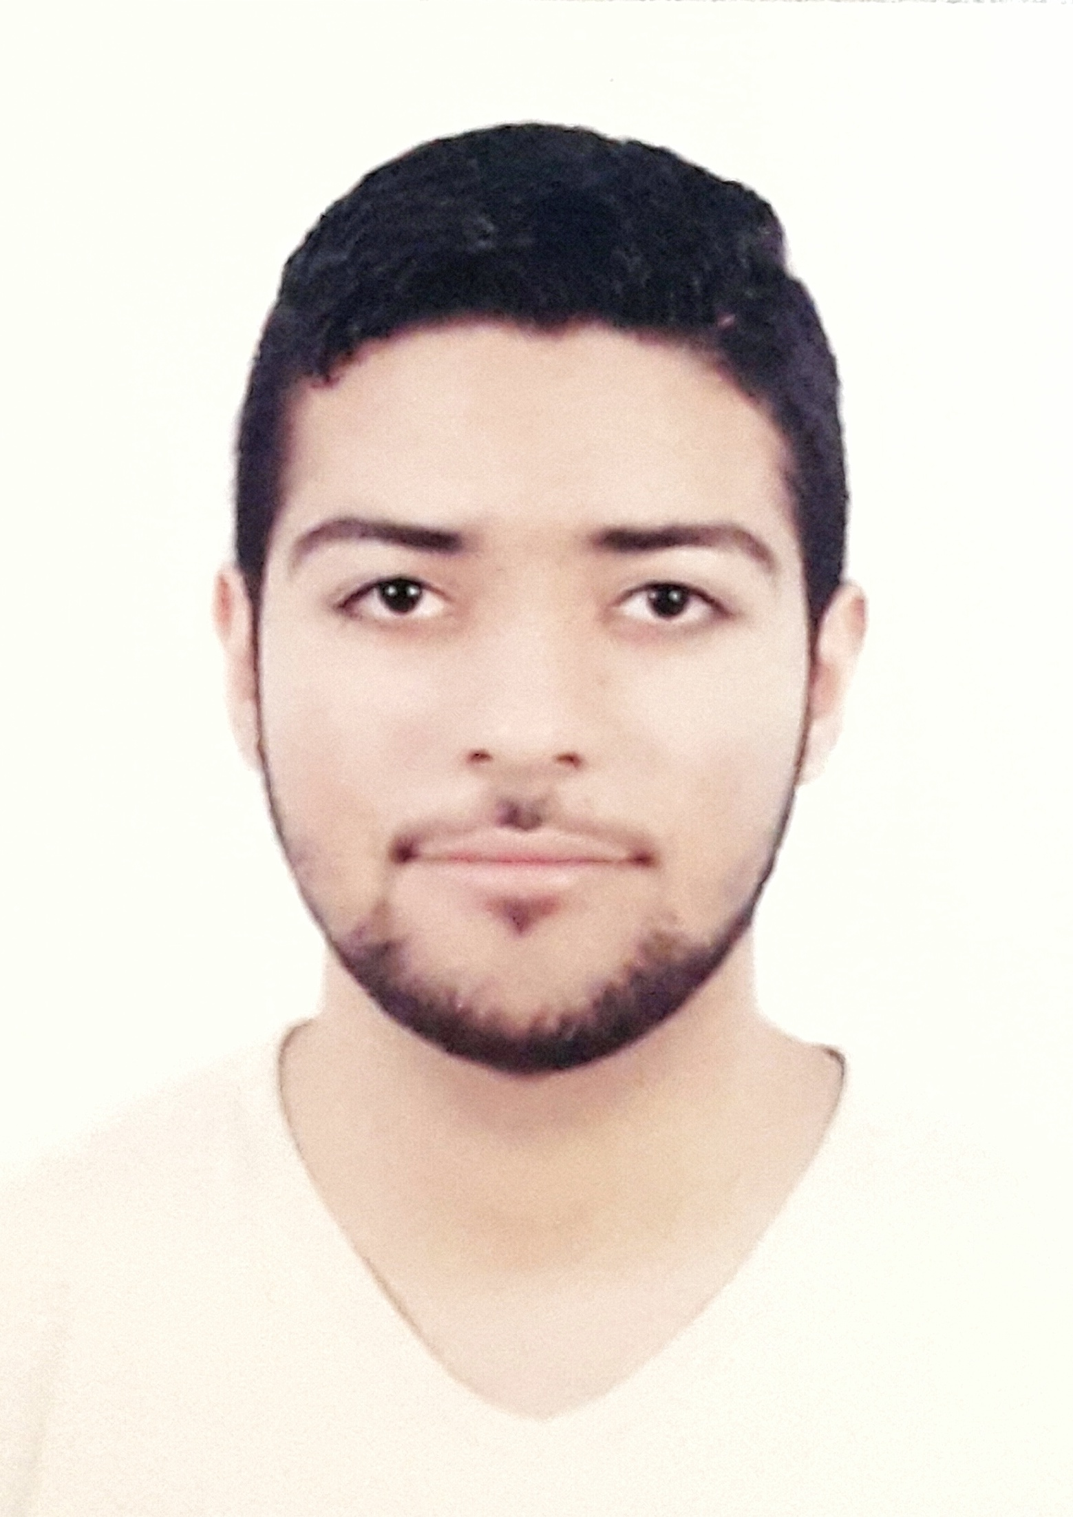

- Name : Ebrahem Ali Abdulnabi Ahmed
- Nationality : Bahraini
- Date of Birth : 24th of July 1995
- Address : House 717 - Road 2913 - Block 729
- Contact No. : 37339979
- CPR. : 950706906
- Marital Status : single
- E-mail : ebrahemosh18@gmail.com

Personal Summary

Hard working graduate with a Bachelor’s degree in Banking & Finance-minor Accounting. Equipped, through hands-on experience, with technical Finance skills and a practical understanding of how to apply Finance and business knowledge. Accuracy and precision in all tasks ensures a high level of efficiency and successful problem resolution. An enthusiastic and motivated individual who is committed to a career in the accounting and finance field.

EDUCATION

2018 Bachelor of banking & Finance - University of Bahrain
2012 Secondary School Cert. – Commercial Major– Isa town Secondary School

WORK EXPERIENCE

- Call center agent – Gulf customer excellence company (3 months)
- Assistant in liabilities department – Ministry of health (2 months)
- Office management & reception – Jurdab society charity (6 months)

Core skills

- Troubleshooting, dismantle and assemble skills.
- Good command over MS Office 2016-2003
- Social communication
- Good manner and behavior
- planning, organizing and effective working in groups

Languages

Arabic: Native Language. English: Good.

